|  |  |  |  |
| --- | --- | --- | --- |
| **Title of paper:** | Safety Needles | | |
| **Meeting date:** | Wednesday 5th April 2023 | | |
| **Agenda item:** | To be completed by APC secretary | **Attachment(s):** |  |
| **Author and contributors:** | Perminder Oberai, Lead Medicines Optimisation Pharmacist | | |
| **Paper type** | Briefing | | |
| **For:** | Agreement | | |
| **Executive Summary:** *(provide a short description of the subject matter and draw attention to the issues / facts and the proposal)*  In June 2019, NHS England produced guidance for CGGs about items which should not routinely be prescribed in primary care (1): <https://www.england.nhs.uk/wp-content/uploads/2019/08/items-which-should-not-routinely-be-prescribed-in-primary-care-v2.1.pdf>  This guidance states:  *‘’for patients that are not able to self-administer it may be appropriate that a safety needle is used by the health care professional, however this would not need to be prescribed on prescription*.’’  In March 2022 the Area Prescribing Committee (APC) agreed that in line with NHS England and The Health and Safety (Sharp Instruments in Healthcare) Regulations 2013: Guidance for employers and employees, all employers of healthcare professionals should provide access to safety needles, and they should not obtain them from an FP10 prescription. (1), (2)  The APC wanted clarification on the situations when a clinician would prescribe safety needles and lancets on FP10. | | | |
| **The APC is asked:**   1. To agree under which circumstances safety needles should be prescribed on FP10. | | | |
| **Accompanying papers** (please list):   1. N/A | | | |

**Current Situation**

In 2019, NHS England updated its guidance on items that should not be routinely prescribed in primary care to include needles for pre-filled and reusable insulin pens. (1)

It advised Clinical Commissioning Groups:

* that prescribers in primary care should not initiate insulin pen needles that cost >£5 per 100 needles for any diabetes patient
* to support prescribers in deprescribing insulin pen needles that cost >£5 per 100 needles and where appropriate ensure the availability of relevant services to facilitate this change.
* For patients that are not able to self-administer it may be appropriate that a safety needle which incorporates an automatic safety lock, is used by the health care professional, however this would not need to be prescribed on prescription.

Since the NHSE guidance was published, there has been significant prescribing of safety needles in Primary Care. (See Graph 1 and table 1)

In March 2022 the APC agreed that in line with guidance the employers of healthcare professionals should provide access to safety needles but further clarification on needle choice and prescribing circumstances was needed.

**Cost implication**

**Cost of safety pen needles and lancets – Drug Tariff February 2023**

|  |  |
| --- | --- |
| **Safety pen needles** | Price |
| Apollo Pro-Shield Safety Pen Needles (OUT OF STOCK ON WEBSITE??) | £9.95 |
| Microdot Max Safety Pen Needles 5mm/30 gauge | £12.89 |
| GlucoRx Safety Pen Needles 5mm/30 gauge ; 8mm/30 gauge | £12.95 |
| Neon Verifine Safety 5mm/31 gauge, 8mm/30 gauge | £14.89 |
| Microdot Safety Pen Needles 5mm/30 gauge | £17.00 |
| Mylife Clickfine AutoProtect 5mm/31 gauge , 8mm/29 gauge | £19.00 |
| GlucoRx Dual-Safe Pen Needles 5mm/31 gauge | £19.95 |
| NovoFine Autocover 8mm/30 gauge | £22.28 |
| Microdot Dual Safety Pen Needles 4mm/31 gauge | £22.95 |
| Dropsafe Safety Pen Needles 6mm/31 gauge , 8mm/31 gauge | £23.00 |
| Unifine SafeControl Safety Pen Needles 4mm/32 gauge 2500 5mm/30 gauge 2200 8mm/30 gauge | £25.00 |
| BD Autoshield Duo | £25.00 |

**It must be noted that the different needles available offer varying protection- some have dual protection mechanisms whilst others do not. The ones with dual protection are more expensive.**

|  |  |
| --- | --- |
| **Safety lancets** | Price |
| Neon Verifine Safety Lancets: 1.8mm/23 gauge, 1.8mm/28 gauge, 1.8mm/30 gauge, 2.4mm/21 gauge | £2.99 |
| Microdot Professional lancets: 2.2mm/23 gauge | £4.25 |
|  |  |
| Safe-T-Lance Plus: 1.4mm/25 gauge, 1.6mm/28 gauge, 1.8mm/18 gauge, 1.8mm/21 gauge | £4.41 |
| Sarstedt Safety Lancets 1.6mm/28 gauge, 1.8mm//21 gauge , 1.8mm/18 gauge | £5.46 |
| GlucoRx Safety lancets: 1.6mm/30 gauge, 1.8mm/28 gauge, 1.8mm/26 gauge, 2.2mm/23 gauge | £5.50 |
| Sterilance Lite II Safety Lancets: 1.8mm/18,21,26,28 gauge , 2.4mm/21 ,26 gauge | £5.70 |
| Apollo Pressure-Activated Safety Lancets: 1.8mm/26 gauge, 1.8mm/28 gauge, 2.4mm/21 gauge | £5.99 |
| Mylife Safety Comfort lancets: 0.32mm/30 gauge | £6.00 |
| On Call Safety Lancets: I 1.8mm/28gauge | £6.00 |

**Safety pen needles and lancets primary care prescribing data for SH ICP 2021 and 2022:**

**Graph 1**

**Table 1**

|  |  |  |  |  |
| --- | --- | --- | --- | --- |
|  | 2021 | 2022 | 2021 | 2022 |
|  | Safety Lancets (£) | Safety Lancets (£) | Safety pen needles (£) | Safety Pen needles (£) |
| ES | 1,377 | 1271 | 10,979 | 9420 |
| G&W | 1,404 | 1402 | 11,038 | 11603 |
| NWS | 551 | 684 | 16,282 | 16641 |
| SD | 3,636 | 3503 | 21,297 | 22844 |
| Total | 6,968 | 6860 | 59,596 | 60508 |

**Graph 2**

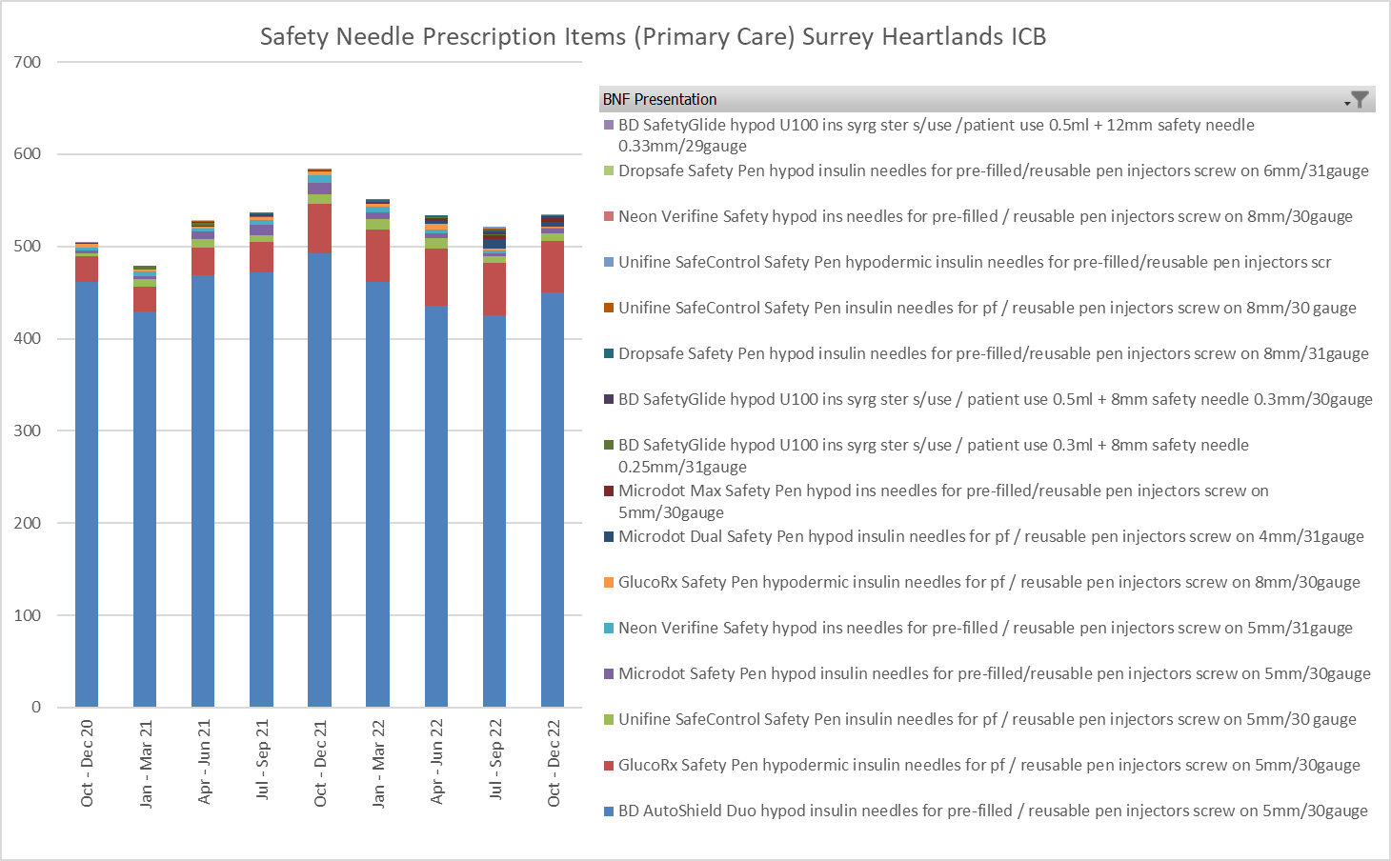

**GRAPH 3**

**SAFETY**

Sharps-related injuries carry the risk of serious blood borne infection. A systematic review was undertaken for the Health and Safety Executive, to consider the evidence related to safer sharps devices and their impact on needle stick injury reduction within the healthcare sector. (2) The review sought to determine whether:

* the use of safer sharps devices could reduce the incidence of sharps injury.
* dedicated educational / training initiatives could reduce the incidence of sharps injuries.
* safer sharps devices were accepted by the hospital personnel asked to use them.
* safer sharps devices had any proven impact on patient care outcomes.

The quality and quantity of evidence was limited, mainly due to study designs used by publishing authors. Despite this, there was sufficient published evidence to consider the use of safer sharps devices to reduce the incidence of sharps injuries amongst UK healthcare workers. Studies showed that when educational programmes were implemented alongside a safer sharps device, lower rates of sharps injuries were sustained for longer. However, the benefit attributable to education alone could not be isolated from the impact of the introduction of the safer sharps device.

The Sharps Regulations: Health and Safety (Sharp Instruments in Healthcare) Regulations 2013, build on the existing law and provide specific detail on requirements that must be taken by healthcare employers and their contractors. All employers are required under existing health and safety law to ensure that risks from sharps injuries are adequately assessed, and appropriate control measures are in place.

The employer must substitute traditional, unprotected medical sharps with a ‘safer sharp’ where it reasonably practicable to do so. The term ‘safer sharp’ means medical sharps that incorporate features or mechanisms to prevent or minimise the risk of accidental injury. For example, a range of syringes and needles are now available with a shield or cover that slides or pivots to cover the needle after use.

**Recommendation:**

1. Employers to provide their employees with safety needles and safety lancets and an FP10 should **not** be generated **unless**:

* for patients whose insulin is administered by a **non-professional healthcare worker** who has been appropriately trained, e.g. carer or relative

**AND** where the patient is known to have a blood born virus e.g. HIV

**OR** known to be aggressive – some dementia patients can become aggressive when insulin injections are needed.

1. Where safety needles and lancets are to be prescribed the most cost- effective product should be chosen that is **<£5 AND <£3 respectively.**

References:

1. NHSE and NHS Improvement: *Items which should not routinely be prescribed in primary care: Guidance for CCGs* ; Version 2, June 2019 <https://www.england.nhs.uk/wp-content/uploads/2019/08/items-which-should-not-routinely-be-prescribed-in-primary-care-v2.1.pdf> ( accessed Feb 23)
2. Health and Safety Executive Information sheet: *Health and Safety (Sharp Instruments in Healthcare) Regulations 2013 Guidance for employers and employees* [*https://www.hse.gov.uk/pubns/hsis7.pdf*](https://www.hse.gov.uk/pubns/hsis7.pdf)(accessed Feb 23)
3. *Drug tariff* <https://www.nhsbsa.nhs.uk/sites/default/files/2023-01/Drug%20Tariff%20February%202023.pdf> (accessed Feb 23)